**AWS ACCOUNT CREATION PROCESS**

**BY RAGHU SIR.**

<https://portal.aws.amazon.com/billing/signup#/start/email>

**1. Enter EMAIL and ACCOUNT NAME (ANY NAME)**

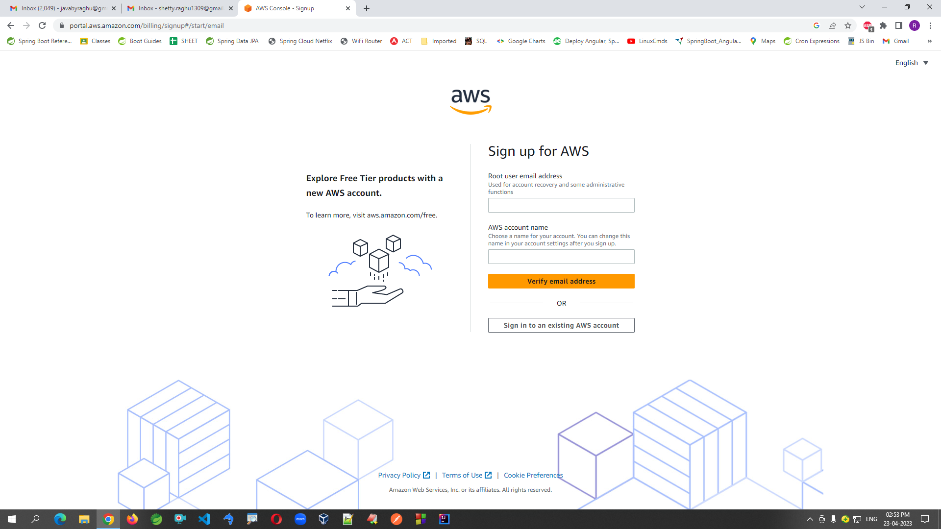

**2. Go to Mail Account for Verification code and paste here.**

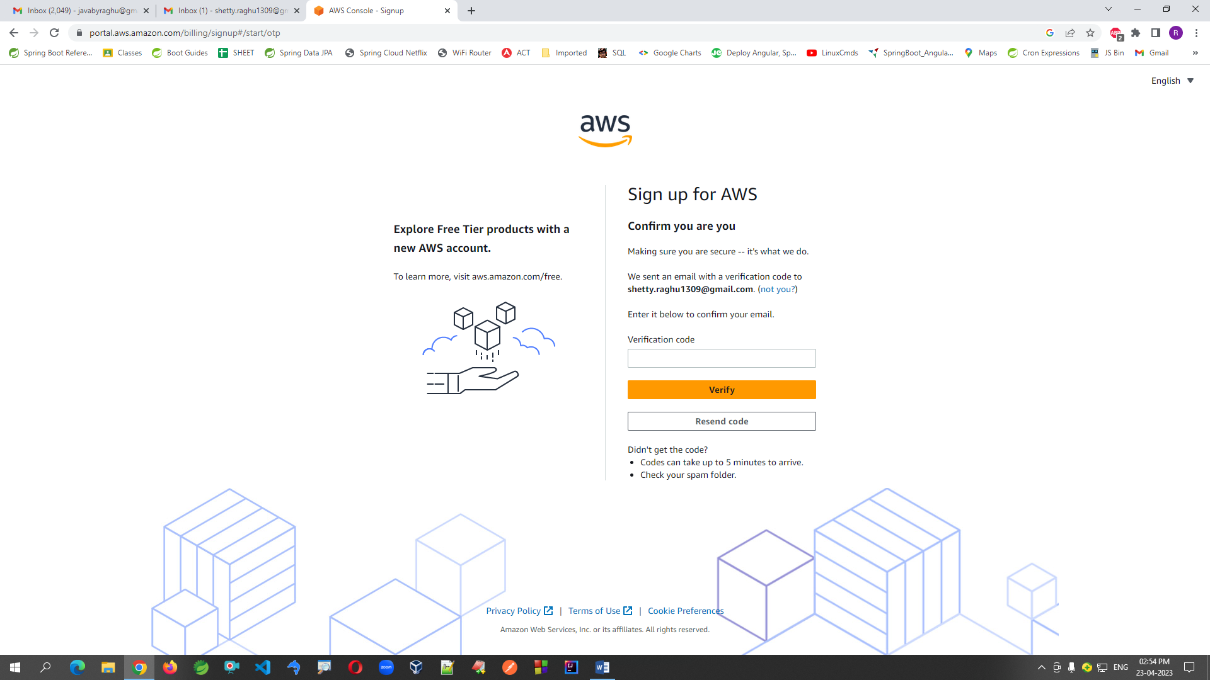

**3. Choose Personal Radio button option and fill your details.**

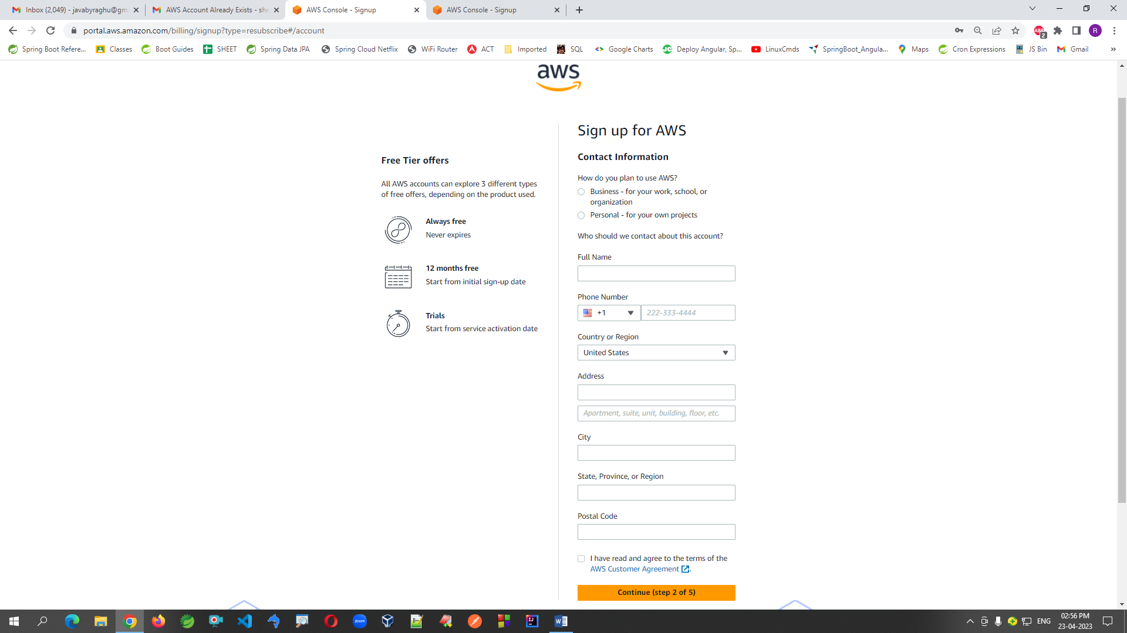

**4. Use credit card or debit card details and fill. (It will charge INR 2.0 for verifications)**

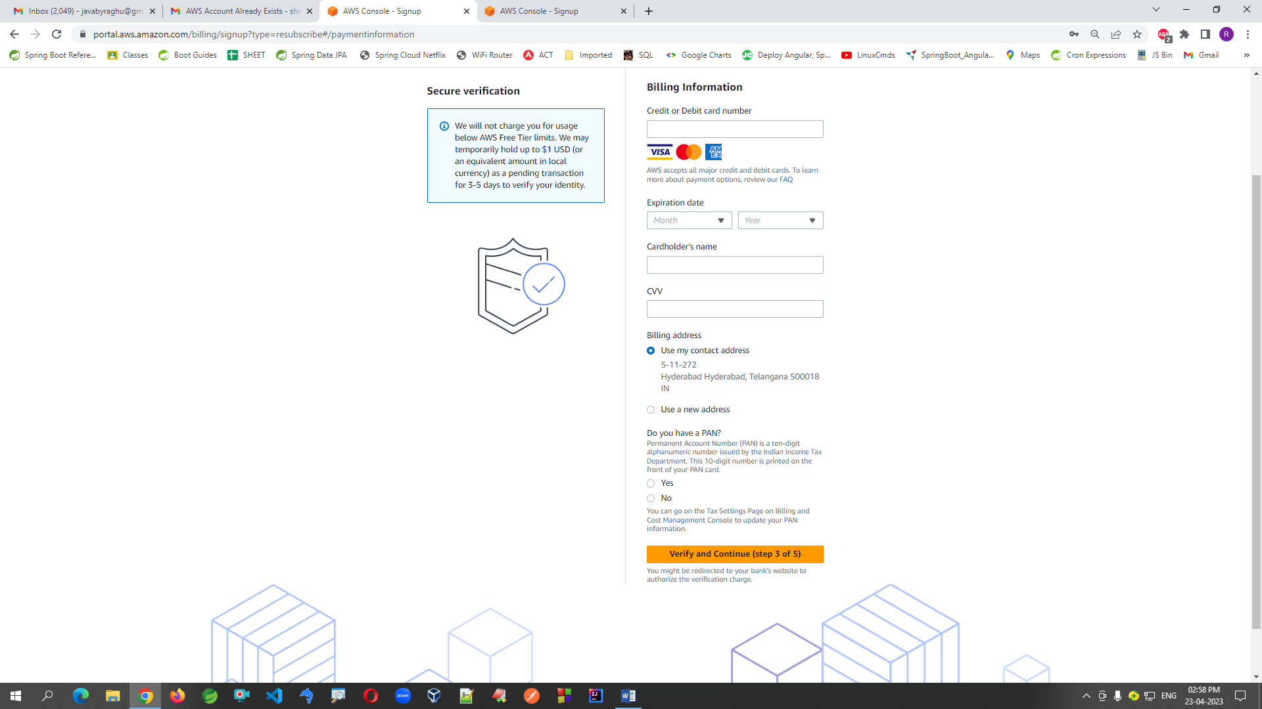

**5. Enter you contact details for verification**

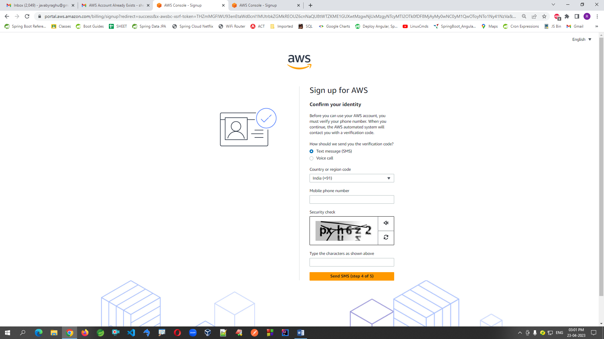

**6. Enter Verification code which you got to your mobile**

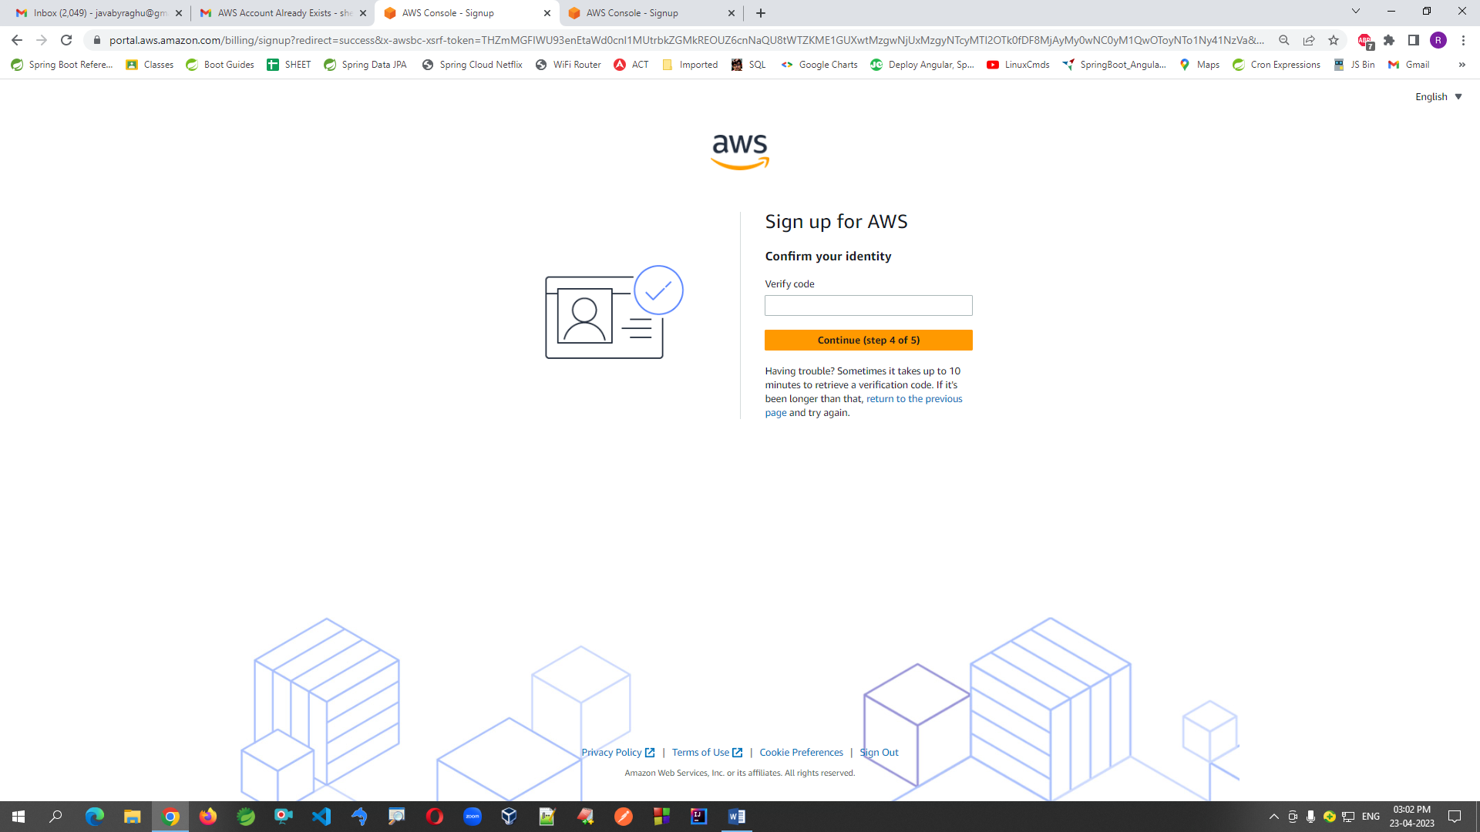

**7. Choose Free Plan option**

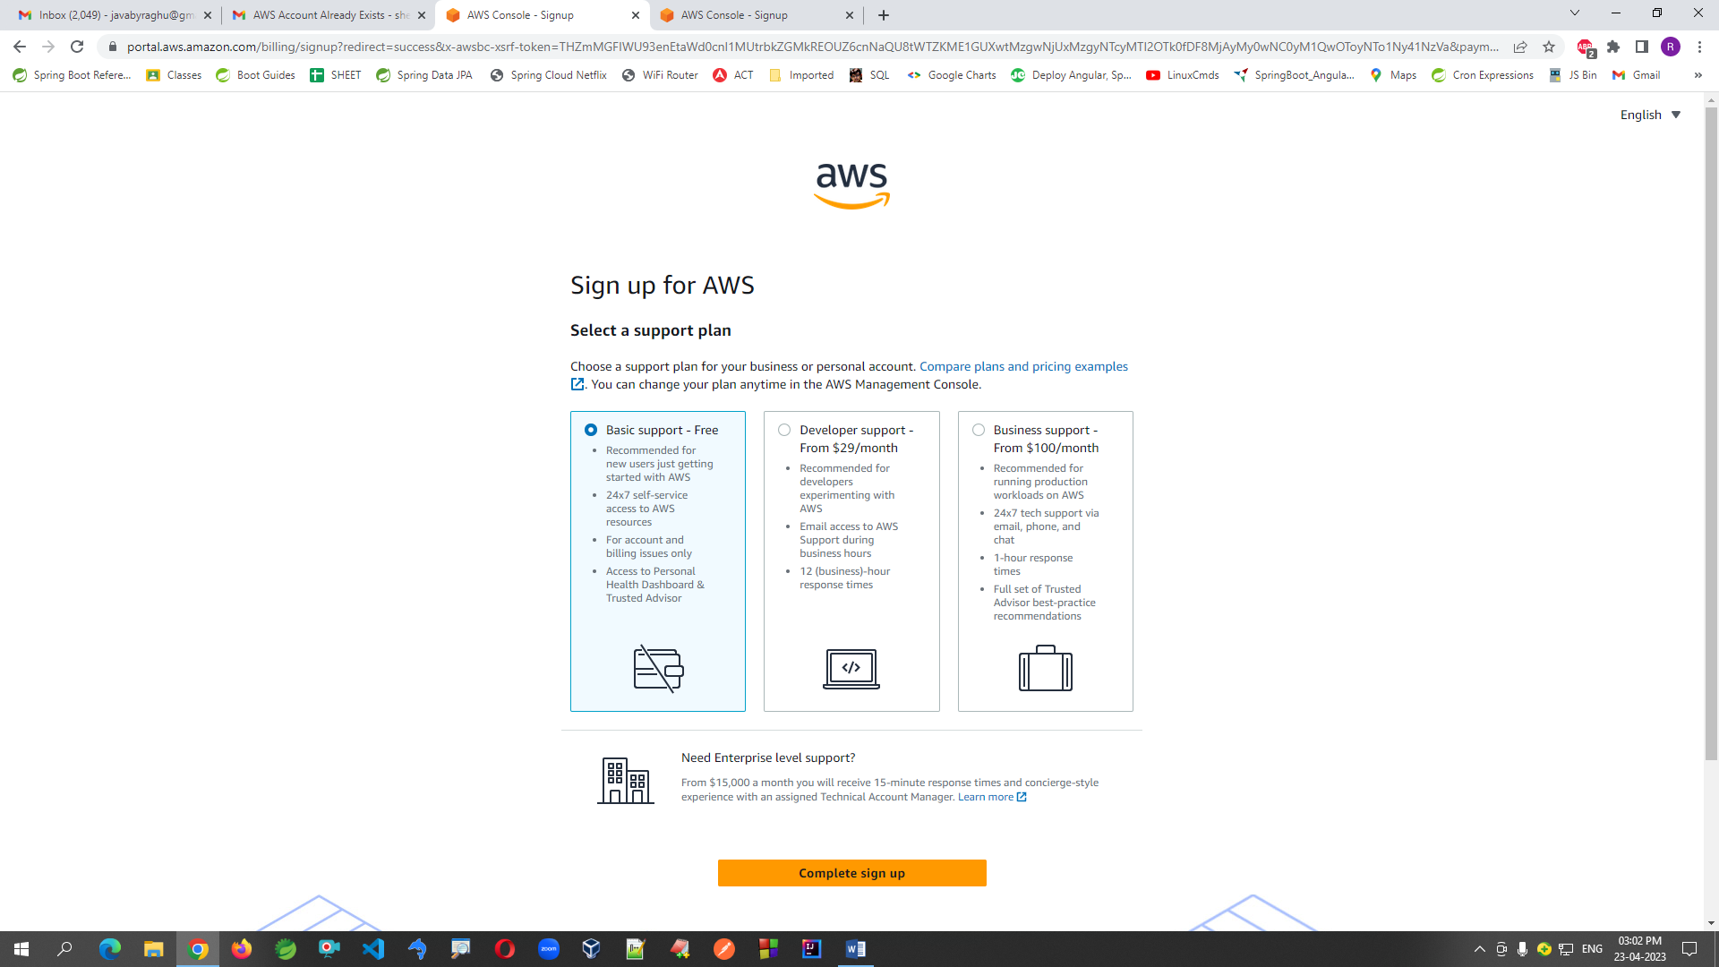

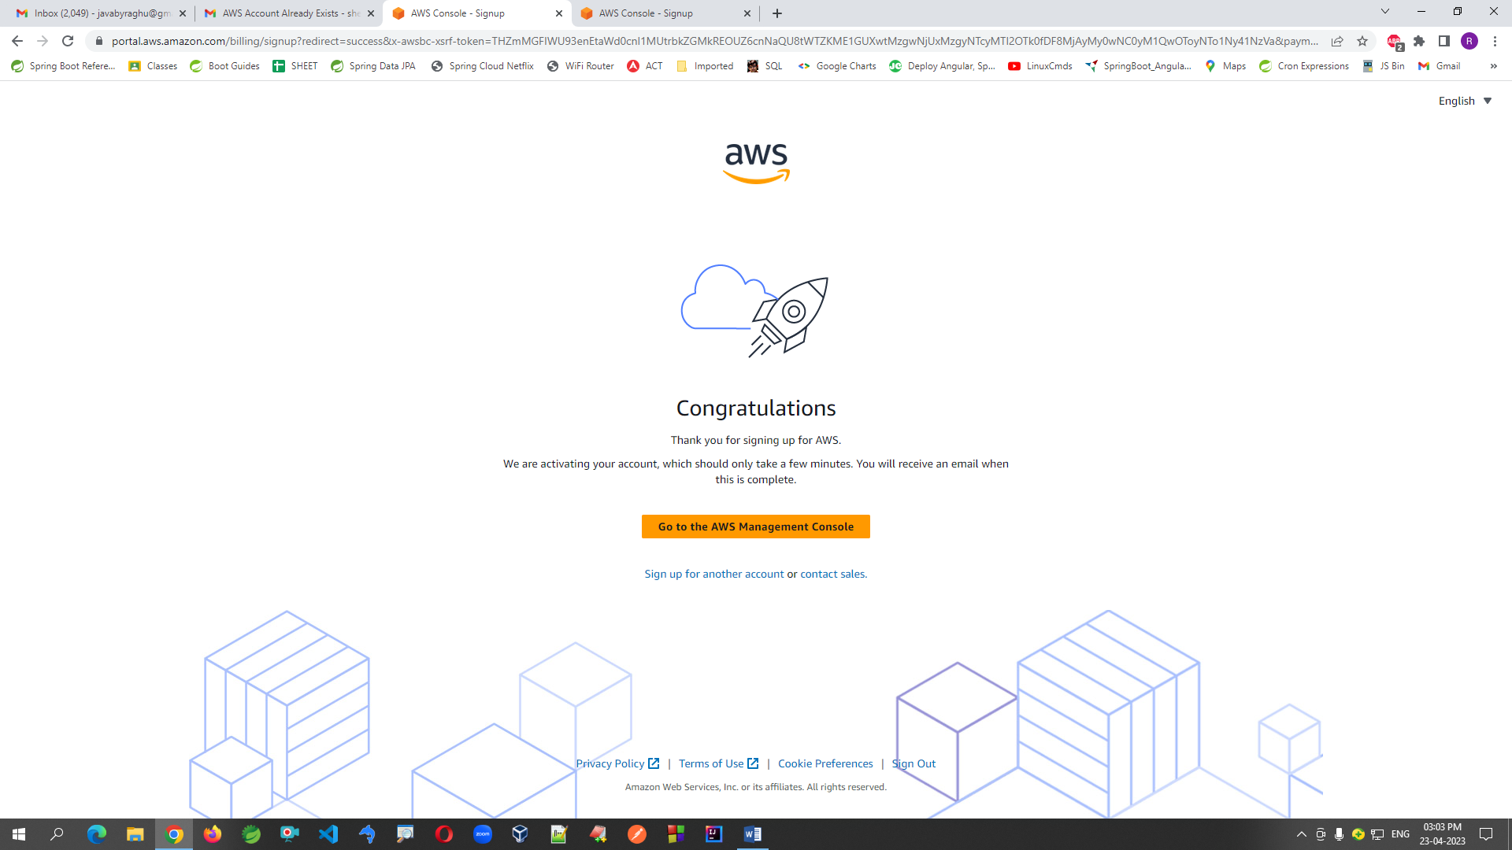

**8. Enter URL for login (or Go to AWS Console using google)**

<https://ap-south-1.console.aws.amazon.com/console/home?region=ap-south-1#>

**FB:** [**https://www.facebook.com/groups/thejavatemple**](https://www.facebook.com/groups/thejavatemple)

**Email: javabyraghu@gmail.com**